Task 3 neural network

GitHub: <https://github.com/dardan-gashi01/DardanGashi_IN3063coursework>

**Introduction:**

In this task I will be creating a neural network from scratch using numpy for the neural network and pandas to load the dataset and split it into train and test data. I will be implementing a sigmoid and ReLU layers in my neural network with a forward and backwards pass. I will also be implementing a SoftMax output layer. I will also be implementing a stochastic gradient descent optimizer that has a stopping criterion also and will be fully parameterized so we can test what factors impact what in our model.

**How I built my model:**

So, to build my model I had to first understand the dataset I am working with. The dataset has 784 columns, so this means we have 784 inputs in the input layer. There are 10 different classes in this dataset T-shirt, Trouser, pullover, Dress, coat, sandal, shirt, sneaker, bag, and ankle boot which means we have 10 outputs in the output layer and 10 hidden layers. This allowed me to draw something like the diagram below to help me understand the work more:

I then done the maths for this model, so I know what I am coding. And the maths I did is below (all the maths done is from lecture 6 slide 64 onwards):

Before we do forward and backward pass, I will generate weights and biases

Forward pass:

Z(1) = W(1)A(0) + B(1). A(0) being the input so in this case X and of size 784 x n_samples

A(1) = σ(Z1) where σ = activation function in my case I will be using the ReLU function

Z(2) = W(2)A(1) + B(2)

A(2) = Softmax(Z(2))

To work backwards using backwards proposition I need to find derivatives using chain rule and the answers I got were:

Backwards pass:

dZ(2) = A(2) – number of out nodes(Y)

dW(2) = (1/size of Y)* dZ(2)A(1)

dB(2) = (1/size of Y)* sum(dZ(2)

dZ(1) = W(2)dZ(2)A(1) * derivative of ReLU(Z(1))

dW(1) =(1/size of Y) *dZ(1)(size of X)

dB(1) = =(1/size of Y) * sum(dZ(1))

This was the maths I worked out using the chain rule and reading from lecture 6.

When implemented fully we get something like

As you can see in this code, we used the ReLU activation function for the forward and backward pass, in the forward pass we used the normal ReLU function so

I also have another version that uses sigmoid instead of ReLU and this function looks like

For this function I was having a problem where I was getting an overflow error because the value was too large, so I had to find a function online that was a more stable version so considered if x is less that 0 or larger than 0 and I found this here[1]

After implementing this it was working and not getting any errors anymore.

**Implementing SoftMax as the output layer:**

This function was in the lab exercises, and I used it for my model. I implemented this for the output layer and took the input z2 which is the sum of the bias and the dot product of the weight and activation function ReLU.

**Implementing a fully parameterized neural network:**

I have made a fully parameterized neural network that takes the input nodes and the output nodes along with the number of hidden nodes and the learning rate.

From the picture above it shows the class Neural network takes 4 inputs as stated above to create an object of that class and we create on by doing:

model = neuralNetwork (X_train, Y_train, 10 ,0.1)

so, the X_train is the number of input nodes which will be 784 in this case, the Y_train is the output which should be 10 because there are 10 classes that we will be getting. The 10 in the third parameter is the hidden nodes we have, and these will be used to adjust the weights and the last parameter in this case its 0.1 is the learning rate of the model.

**Implementing stochastic gradient descent:**

I decided to implement SGD as an optimizer instead of Adam. Adam converges faster which is an upside to using Adam however SGD generalises better than Adam which is why I decided to choose gradient descent instead of Adam.

To work out gradient descent we must use the formula

Wnew = wold − α[gradeint] where α is the learning rate and is the same as what I did with:

In my gradient descent I did it for both weights so one in first layer and one in the second whilst also doing it to the bias values. The weights are defined earlier in the program along with the bias values and then I used the -= to update the value of the weights and biases to be learning rate multiplied by the derivative of the weights and the biases as that is equal to the gradient and I did data in the backwards propagation as shown above on the second page and I used chain rule to work that out for example:

self.w2_delta = scaling * self.z2_delta.dot(self.a1.T)

when I do this, it then means that the weights will keep updating on every epoch and tries to find the local minimum to maximize accuracy in the model.

To visualise it we can use figure 1.1 on the last page and we can see how the weight decreases after every epoch and reaches the local minima at the bottom however we do not want to overfit the values and go past the minima to be inefficient so we add a stopping criteria which I will be talking about in the next section about how I implemented my stopping criterion and what I made the stopping criterion.

**Implementing a stopping criterion:**

I implemented a stopping criterion in my model for gradient descent. The criteria I gave it is when the accuracy only increases by less than 0.2% twice in a row. For example if have a list of accuracies and the last 3 show 50,50.1,50.2 the difference of these are 0.1 and 0.1 for both this means the accuracy is not increasing that much anymore and is flattening out so I want a stopping criteria for this and the way I implemented this was by creating the function below:

def difference(arr):

return [item-arr[i-1] for i, item in enumerate(arr) if i != 0]

this function I created will create a new list of the difference of the current value and the previous one so for example like above it would have a new list [0.1,0.1]. so in my training function I have got a condition with this function like this:

diff = difference(acc_list[-3:])

if len(diff) > 1:

if(diff[-1] < 0.2 and diff[-2] < 0.2):

break

so this function first checks if the new array we made using the function is big enough to iterate. When it is greater than a size of 1 then we always take the last 2 values and check if they are both smaller than 0.2 then the program calls break so it stops the training loop and carries on the rest of the code.

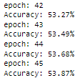An example of this happening in practise is:

From this example we get an array of [0.22, 0.19,0.19] because the last 2 values are less than 0.2 the program then stops the function running and ends training because then the model is not going to be increasing accuracy too much anymore.

The reason I add the stopping criteria is so we don’t get a graph like this:

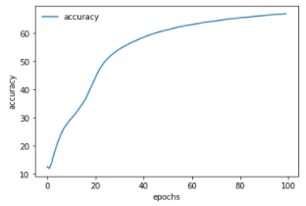This graph shows that when we get to the end of training the line flattens out so doesn’t make too much progress anymore and this is the reason we add a stopping criteria so we don’t pass the local minimum and we are at the optimal place.

The graph we get after we add the stopping criteria is a bit different and isn’t as flat as the first one which shows that it gets to the local minimum and is quite optimal:

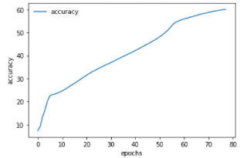

Overall this shows that the stopping criteria I added is so we don’t waste more time training for a very small increase in accuracy in a row and we can then have faster running times due to this.

**How parameters affect the outcome of the accuracy:**

The parameters I had that could affect the outcome of the accuracy is the number of epochs and the learning rate and I will be discussing how both of these impact the model and the accuracy. I will run these all with no stopping criteria to get a better look at the end of the epochs.

Learning rate:

The learning rates I used for testing are 0.1 and 0.01 we expect to see the higher the learning rate the higher the result and the running time will be different, we will be running these for 100 epochs.

Learning rate = 0.01:

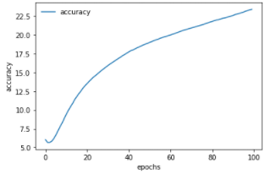

For this model we can see that the accuracy only goes to 22.5% accuracy which is not too good for this model and the learning rate is not the best

To run this code I used:

model = neuralNetwork(X_train,Y_train, 10 ,0.01)

acc = model.SGDTrain(100)

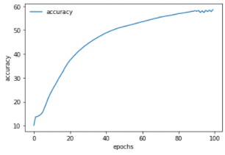Learning rate 0.1:

This learning rate takes us to 60% accuracy which is 3 times the amount of the 0.01 learning rate model and this shows that this learning rate is better overall for this model

To run this code I used:

model = neuralNetwork(X_train,Y_train, 10 ,0.1)

acc = model.SGDTrain(100)

I also ran the learning rate 0.001 and it only got to the accuracy of 16% so due to this the learning is directly proportional to the accuracy because the higher the learning rate the higher the accuracy at the end of 100 epochs.

Epochs:

The expected outcome I expect is the more the epochs the higher the accuracy however I think we will get a strong level off at the end and the accuracy won’t be increasing too much at the end and that’s why I implemented a stopping criteria to prevent this.

We will be running all of these with a learning rate of 0.1 so we have a fair result so the code I will be running is   
acc = model.SGDTrain(100)

And acc = model.SGDTrain(500)

100 epochs:

For this we already have the answer above where we got the accuracy of 60% with the graph at the top of this page. This shows that the accuracy is still really good even with the 100 epochs ran.

500 epochs:

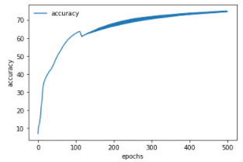

This graph shows that we get to an accuracy of over 70% and to be exact, from looking at the code, it was 74% which is better than the 100 epochs model by 14% more but as you can see it levelled out so wasn’t changing much and also it got 14% more for a cost of running for 5 times longer than 100 epochs so due to this it is not a good model.

We managed to see that 100 epochs is better to run that 500 due to it taking less time to run for a more optimal result and that is one reason why I implemented a stopping criteria so we wouldn’t have to run into this problem if we ran very large models of high epochs.

**Evaluation:**

Overall in this task I managed to implement the sigmoid and the ReLU layers into the forward and backwards pass with the functions I showed on page 2 and those worked well but figured out that ReLU did work better than the sigmoid function from running the program. I also managed to implement a softmax layer into my model, which is on page 2 with the function and when I implemented it in the forward pass. I also did make a fully parameterised model that we can change the learning rate, number of hidden layers and the number of epochs that are ran on the model so we can test numerous outcomes. Another thing I learnt was how to implement gradient descent on my model using the lectures and managed to do that as displayed on page 3 where I explained the code I made and what it does along with a stopping criteria to make it more efficient and try and get as close to the local minimum and not over fit the model. I did also managed to do backwards propagation on my model which can be found on page 1 and 2 where I explain the maths I did and the code I made for it, I learnt all of that from the lectures and this youtube video[2]. And finally I managed to evaluate how different factors such as number of epochs and learning rate impact the accuracy of the model using graphs as evidence for it and compared and contrasted the results from that.

Figure 1.1

1. https://shaktiwadekar.medium.com/how-to-avoid-numerical-overflow-in-sigmoid-function-numerically-stable-sigmoid-function-5298b14720f6
2. Youtube.com. 2021. [online] Available at: <https://www.youtube.com/watch?v=Ilg3gGewQ5U&ab_channel=3Blue1Brown> [Accessed 14 December 2021].